Organisation des Séances

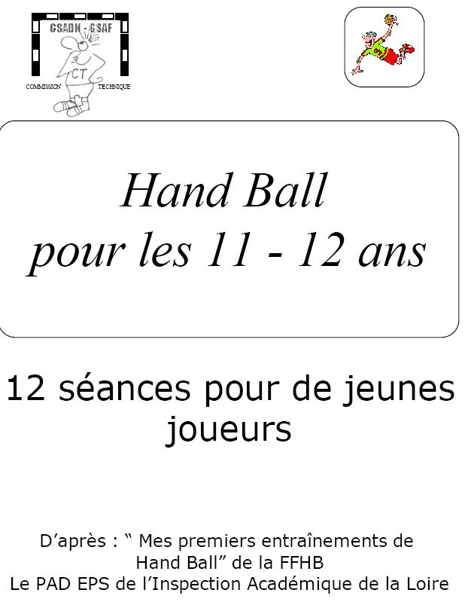  
  
  
  
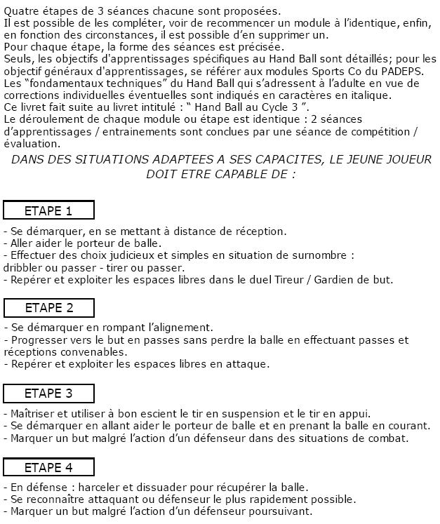  
  
  
  
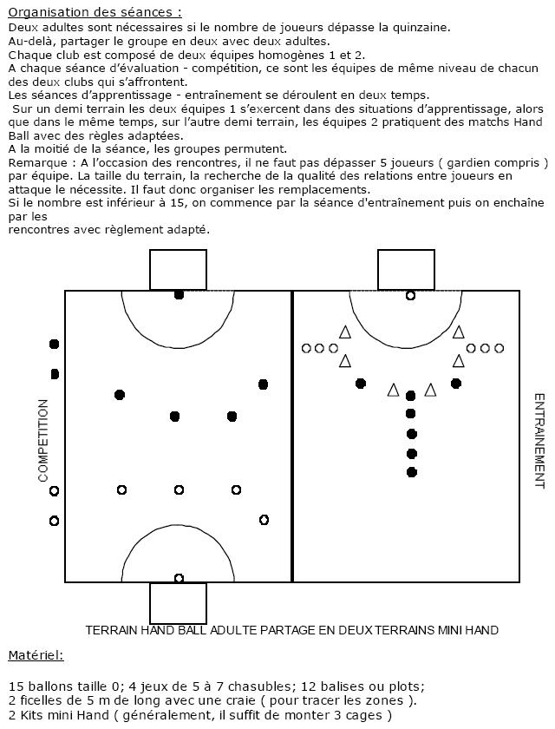

Etape 1

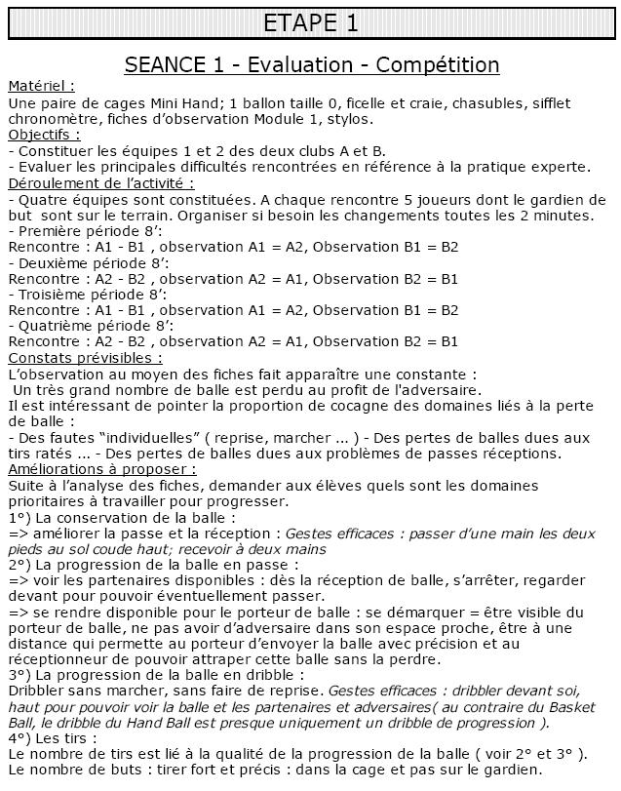  
  
  
  
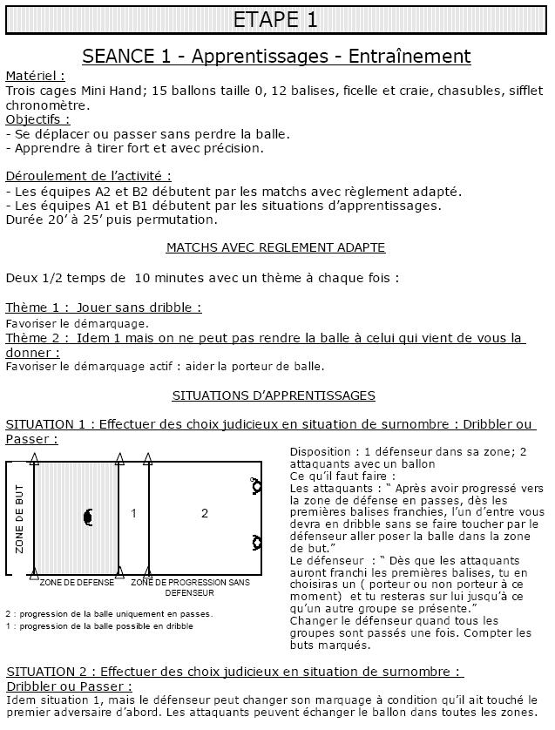  
  
  
  
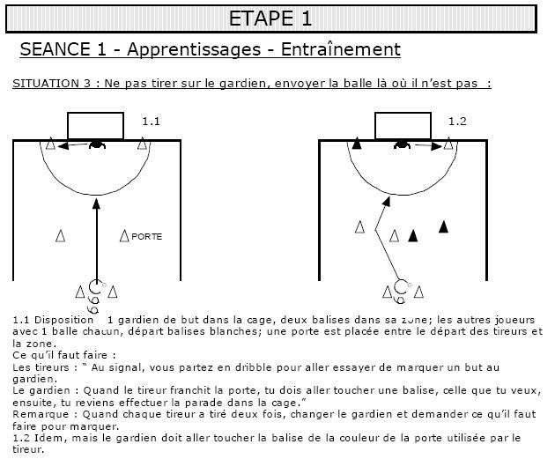  
  
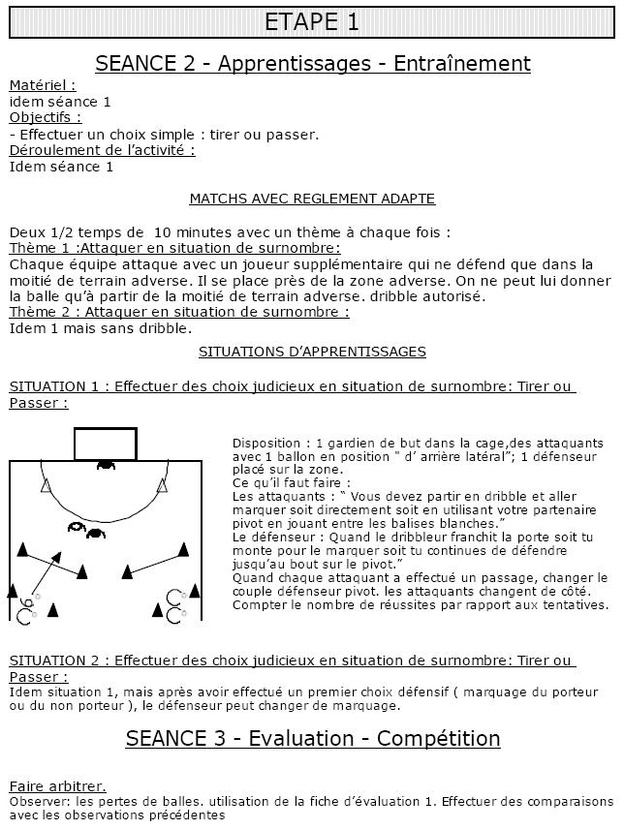

Etape 2

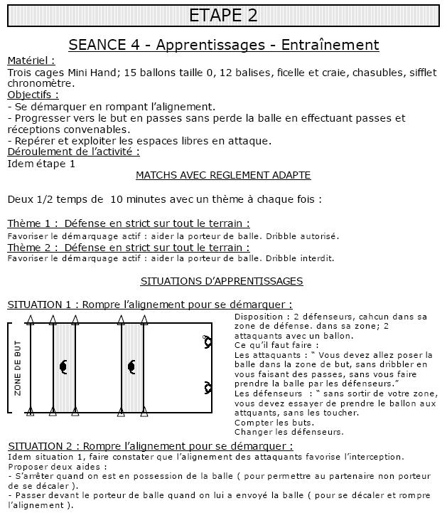  
  
  
  
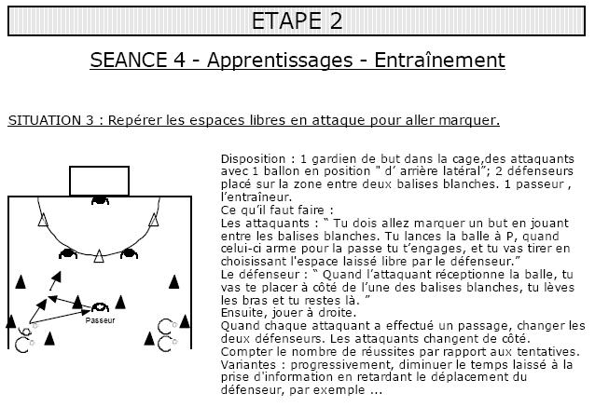  
  
  
  
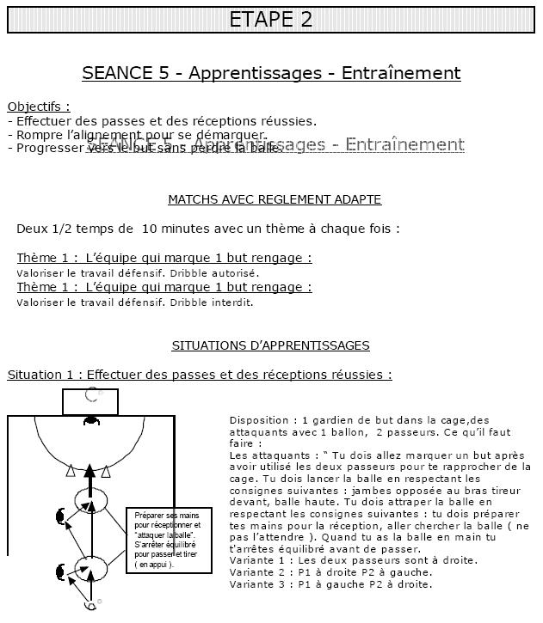  
  
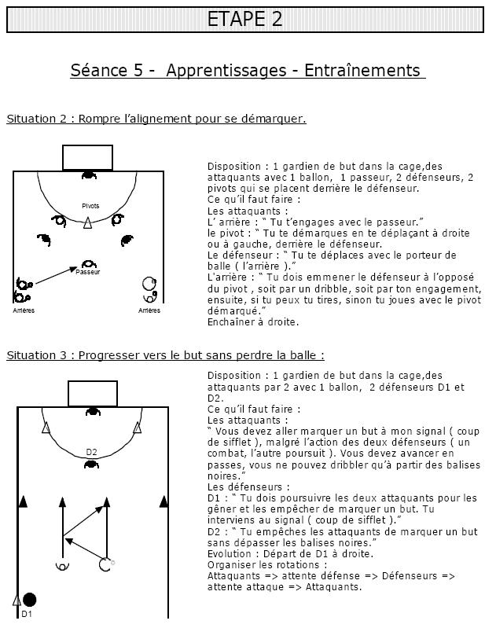  
  
  
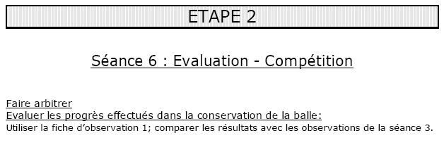

Etape 3

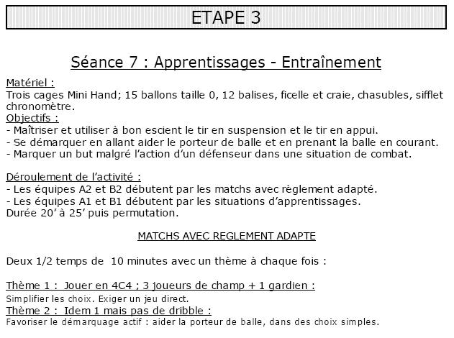  
  
  
  
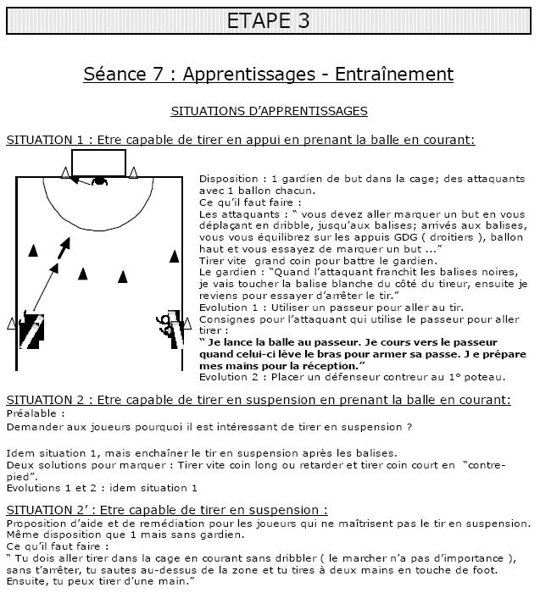  
  
  
  
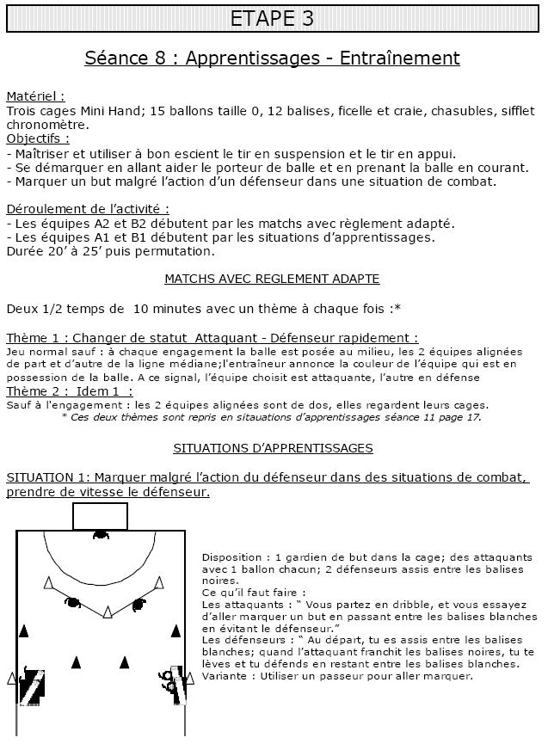  
  
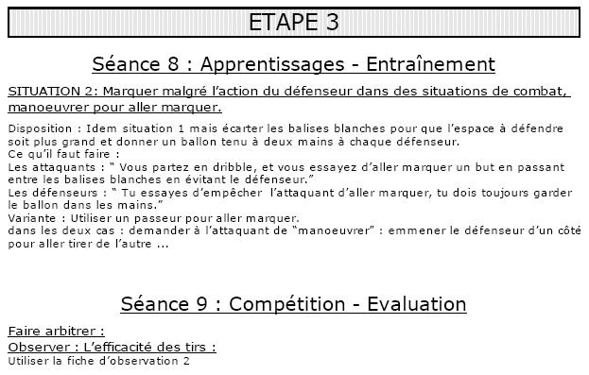

Etape 4

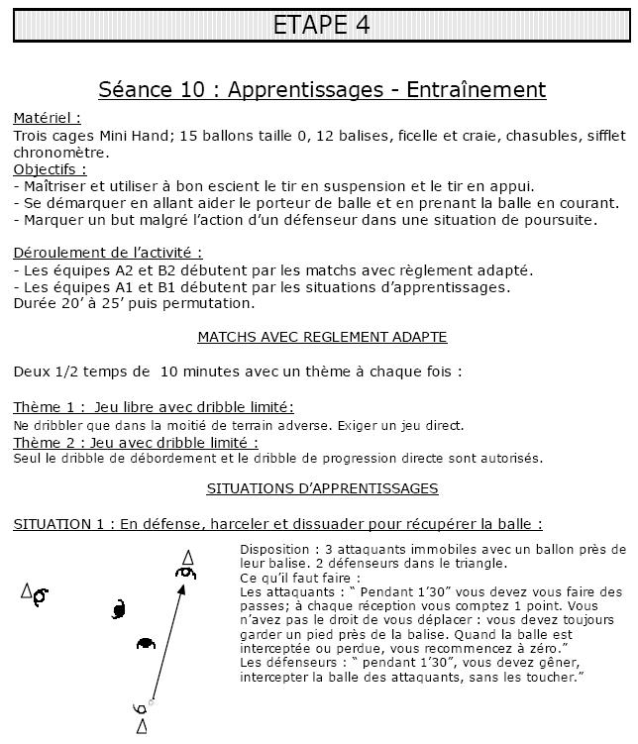  
  
  
  
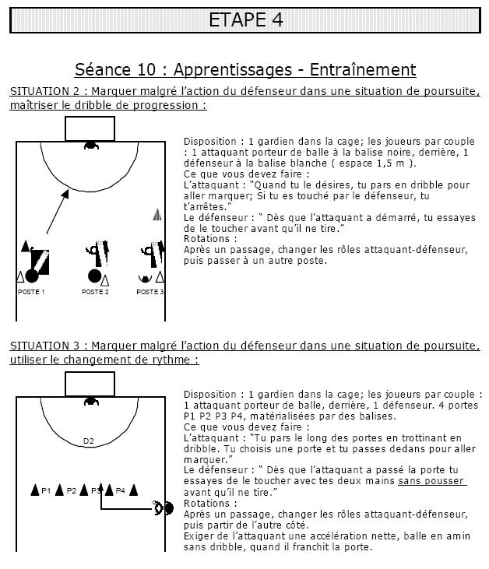  
  
  
  
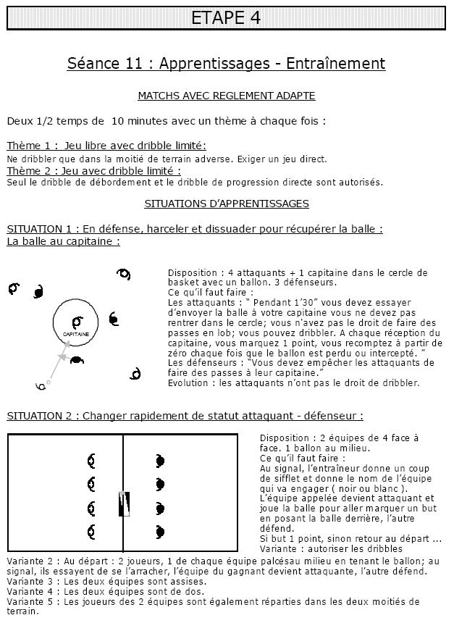  
  
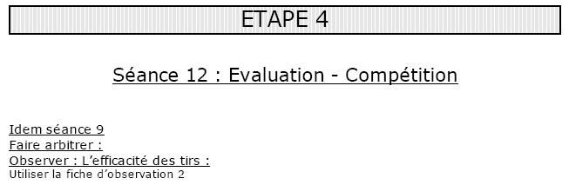

Fiches d'Observation

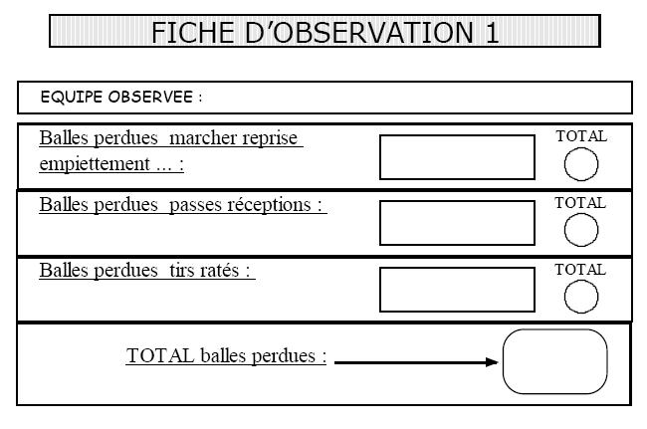  
  
  
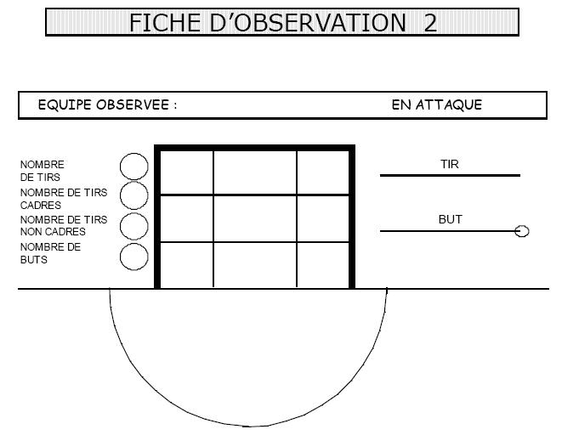

#### Handball pour les 11-12 Ans :

[Organisation des Séances](http://www.handball-club-pleyben.net/pages2referentiels/referentiels00130.html)  
[Etape 1](http://www.handball-club-pleyben.net/pages2referentiels/referentiels00131.html)  
[Etape 2](http://www.handball-club-pleyben.net/pages2referentiels/referentiels00132.html)  
[Etape 3](http://www.handball-club-pleyben.net/pages2referentiels/referentiels00133.html)  
[Etape 4](http://www.handball-club-pleyben.net/pages2referentiels/referentiels00134.html)  
[Fiches d'Observation](http://www.handball-club-pleyben.net/pages2referentiels/referentiels00135.html)